From Lake Charles, LA

Go To I-10 & US-171 N
Merge onto US-171 N - toward Shreveport/Deridder.
US-171 N becomes US-190 W
(Crossing into Texas).
In Deridder Turn left onto US-190/TX-505.
Continue to follow US-190 W.
Go Passed Towns of Newton - Jasper - Woodville
Go Under US 59 in Livingston
Take Hwy 190 West to the City of Onalaska.
DON’T SPEED!!
Go through town to FM 356.


(Shell on the Right)
Turn Right on FM 356
Drive until you see FM 355
(Groveton) (Fifteen - Twenty Minutes)
Go Pass (Do Not Turn Here) FM 355
a/k/a Road to Groveton.

Harbor Point will be coming up
on the right hand side on FM 356.
(1/8 Mile past the Old Store)

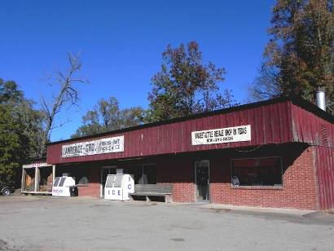
Turn Right in to
“Harbor Point”
You Will Arrive at the Security Gate.
Tell the Person on Duty
who you are visiting.
To Save Time, Please Advise The Property Owner To Notify The Front Gate Before Your Arrival.
HP Gate Phone Number: 936.594.2099

